JUDICIAL COMMITTEE

Minutes of a Meeting held via Zoom on Tuesday 9 May 2020
Present:
House of Bishops  House of Clergy  Tikanga Māori | Bishop Steven Benford  The Rev’d Joel Rowse  Vacancy  Vacancy
Tikanga Pākehā | Judge Chris Harding (Chair)  Judge Anne McAloon  Ms Brigit Brant
Tikanga Pasefika | Mr Walton Morgan  Ms Mele Taliai
General Secretary | Rev’d Michael Hughes

Bishop Steven led an opening prayer.

The Chair noted that initial tasks included determining who were the interested parties, setting timeframes, and whether an interim hearing should be called in view of the requests for interim relief.

After Zoom connection difficulties, Judge Anne took over the Chair.

The Committee agreed that persons practically interested would include the Bishop of Auckland, the King’s College Board of Trustees, the King’s College Governors, and the Diocesan Council in addition to those statutorily required to be served.

Judge Chris resumed the chair.

A question was raised as to whether the application was legitimately a matter for the Judicial Committee. It was noted that the actions taken by the Auckland Diocesan Council were taken pursuant to Parliamentary Statutory Authority in the form of section 9(2) and 19(2) of the Anglican Church Trusts Act 1981, rather than pursuant to the Canons of the church. The Committee’s preliminary view was that it may not have jurisdiction to consider this application given the Parliamentary rather than canonical authority of the Diocesan Council.

The Committee after further discussion also doubted that in the circumstances before it, it had authority or jurisdiction to make orders of the nature sought by the applicant in particular:
1. An interim decision to overturn the decision made by the Standing Committee of the Auckland Diocese.

2. An order that the primates enforce the interim decision by having the Chancellor for General Synod or an equivalent office holder file injunctions to any relevant Court.

3. Make it direct that the Diocese of Auckland or its Standing Committee and the Bishop of Auckland not submit a dissenting opinion or be a party to one that will be submitting a dissenting opinion in a Secular Court.

4. Precluding such bodies from being a body interested for the purposes of the Judicial Committee for this particular case.

The Committee was of the preliminary view that none of those requests were within its jurisdiction or power, and that the applicant’s remedies, should there be any, probably lie elsewhere.

The Secretary indicated he had been asked by the Chair to enquire into the present status of the land. The Committee was advised that the land had been sold, with settlement to take place in parts commencing in June of this year.

Members expressed concern as to the range of persons suggested by the appellant to be affected and therefore served, in the absence of any explanation from him as to how a number of them are said to be involved or entitled to be heard.

Before considering the question of service, the Committee unanimously resolved to invite the applicant to file written submissions as to the jurisdiction it has and its powers to grant the remedies sought.

If the Committee is persuaded that the matter of complaint is within its jurisdiction, and the remedies within its powers, it will proceed to direct service as the Canon requires.

If the Committee is not satisfied as to those matters it indicates an intention to decline considering the matter further.

It was unanimously resolved that the Secretary be invited to contact the applicant, and to provide to the applicant a copy of these Minutes and invite him to make submissions as to the matters discussed within 14 days following the secretary emailing the applicant after which the Committee will again meet to consider the position.

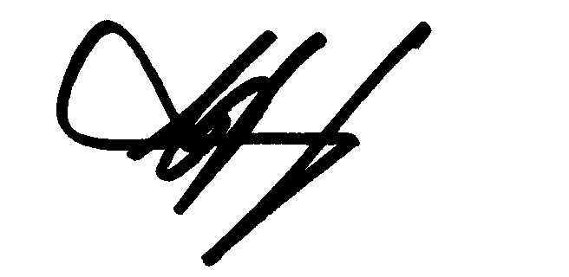
______________________________
C J Harding
Chair
20 May 2020

